USN

RNS Institute of Technology
Department of CSE
VI Semester - III Test – Aug 2021
Computer Graphics and Visualization (18CS62)

Duration: 90 mins. Max Marks: 50 Time: 3:00-4:30 pm Date: 03/08/2021

NOTE: Answer FIVE full questions.
Don’t write anything on question paper other than USN.
Qn.  No. |  | Questions | Marks | BCL | CO
1 | a) | Define clipping. | 2 | L1 | CO3
 | b) | Discuss with example Cohen-Sutherland line clipping algorithm. | 6 | L2 | CO3
 | c) | What is affine transformation? | 2 | L1 | CO3
OR
2  VISION: Preparing better computer professionals for a real world | a) | Explain Sutherland Hodgman polygon clipping. | 5 | L2 | CO3
 | b) | Find the final clipped vertices for the following figure using Sutherland Hodgman polygon clipping.  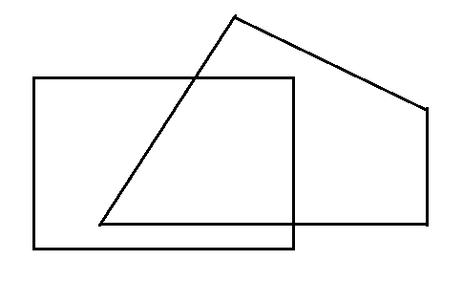 | 5 | L3 | CO3
3 | a) | Write an OpenGL program to clip a lines using Cohen-Sutherland algorithm. | 7 | L3 | CO3
 | b) | Briefly discuss the three-dimensional Viewing-Coordinate Parameters. | 3 | L2 | CO3
OR
4 | a) | Differentiate between parallel projection and perspective projection. | 6 | L4 | CO3
 | b) | What is vanishing point? Explain different types of perspective projections with respect to vanishing point. | 4 | L2 | CO3
5 | a) | List the basic types of light sources. Explain any two with neat diagram. | 1+4 | L2 | CO3
 | b) | Briefly explain the Phong model. | 3 | L2 | CO3
 | c) | List the light source properties. | 2 | L1 | CO3
OR
6 | a) | Write an OpenGL program to draw a color cube and allow the user to move the camera suitably to experiment with perspective viewing. | 8 | L3 | CO3
 | b) | Discuss RGB color model. | 2 | L2 | CO3
7 | a) | Explain the following OpenGL functions  i). gluPrespective() ii). glLookAt() | 6 | L2 | CO3
 | b) | Define Orthogonal Projection. | 1 | L1 | CO3
 | c) | Briefly discuss 3D viewing pipeline | 3 | L2 | CO3
OR
8 | a) | Explain the following OpenGL functions with syntax  i). Point-light source and Light source colors function.  ii). Surface property functions. | 4+4 | L2 | CO3
 | b) | Explain any one of the 3D transformations. | 2 | L2 | CO3
9 | a) | Write an OpenGL program to display a Teapot. Define suitably the position and properties of the light source along with the properties of the surfaces of the teapot in the scene. | 7 | L3 | CO3
 | b) | Define ambient light, diffuse reflection and specular reflection. | 3 | L1 | CO3
OR
10 | a) | Discuss Depth buffer method along with algorithm. | 6 | L2 | CO3
 | b) | Explain the following OpenGL visibility detection Functions  i). glCullFace() ii). glFogi() | 4 | L2 | CO3

Course Outcomes (CO):

CO3: Apply concepts of clipping and visible surface detection in 2D and 3D viewing, and illumination models.

